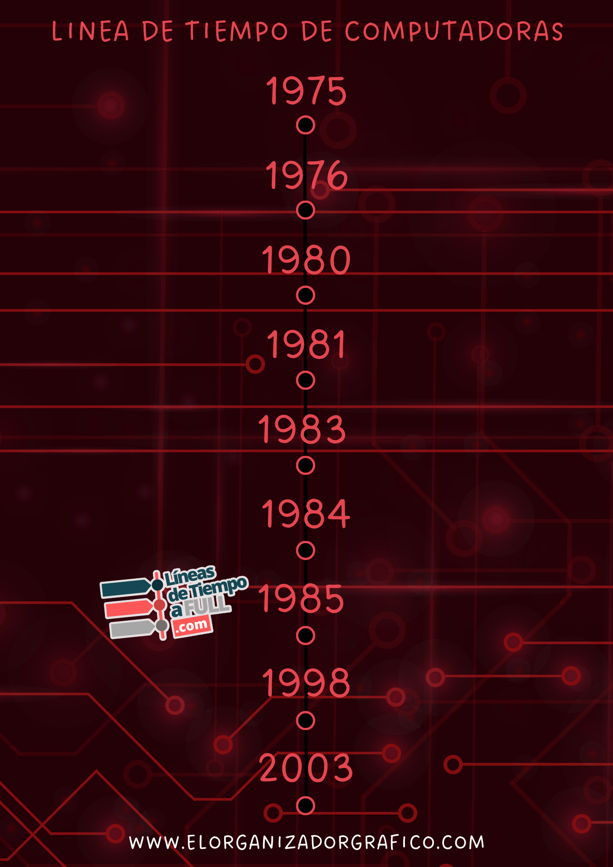

POWER MAC G5

IMAC

ATARI ST

MACINTOSH

IBM XIT

BBC MICRO

LISA

COMMODORE VIC-20

APPLE 1

ALTAIR 8800